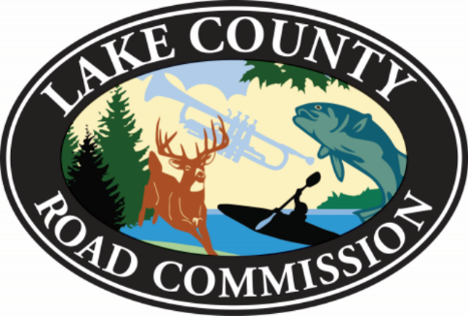

Lake County Road Commission

Big Star Lake District

Special Assessment Role Public Hearing

Monday, June 26, 2017 at 6:00 p.m.

1. Call to Order: Road Commission Manager
2. Pledge of Allegiance
3. Public Hearing on Big Star Lake Level Special Assessment District
4. Assessment Spread
5. Public Comment
6. Adjournment

All agendas are subject to change

Baldwin Community Schools

High School Gymnasium

525 Fourth Street

Baldwin, MI 49304

