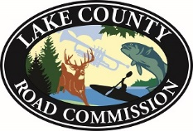

1180 Michigan Avenue

Baldwin, MI 49304

231-745-4666 Fax 231-745-6227

[roads@lcrc-roads.com](mailto:roads@lcrc-roads.com)

**NOTICE**

THE **NOVEMBER 9, 2023** MEETING OF THE LAKE COUNTY BOARD OF ROAD COMMISSIONERS HAS BEEN RESCHEDULED FOR NOVEMBER 8, 2023 AT 9:00 AM.

WILLIAM VANDYKE

Finance & HR Manager

POSTED OCTOBER 3, 2023 AT 7:00 AM